What to Watch - Best Movies About Racism

Documentaries
- Black Power Mixtape: 1967-1975 (Directed by G. Olsson, 2011)— Available on Amazon
- 13th (Directed by Ava DuVernay, 2016) — Available on Netflix or you can watch below
- White Like Me – Based on Tim Wise’s book above. (Directed by Scott Morris) Watch for free below
- I Am Not Your Negro (Directed by Raol Peck – James Baldwin doc, 2016) — Available on Kanopy
- The Black Panthers: Vanguard of the Revolution (Directed by Stanley Nelson Jr., 2015) — Available on Amazon
- King In The Wilderness (Directed by Peter Kunhardt, 2018) — Available across many streaming services including Hulu and HBO Max. You can also watch below.

Movies / Shows
- Do the Right Thing (Directed by Spike Lee, 1989) — Available across many streaming services.
- Boyz N the Hood (Directed by John Singleton, 1991) — Available on Hulu
- 12 Years a Slave (Directed by Steve McQeen, 2013) — Available across many streaming services.
- Selma (Directed by Ava DuVernay, 2014) — Available across many streaming services.
- The Hate U Give (Directed by George Tillman Jr., 2018) — Available to rent for free.
- Fruitvale Station (Directed by Ryan Coogler, 2013) — Available across many streaming services.
- Moonlight (Directed by Barry Jenkins, 2016) — Available on Netflix
- Get Out (Directed by Jordan Peele, 2017) — Available across many streaming services.
- If Beale Street Could Talk (Directed by Barry Jenkins, 2018) — Available on Hulu
- Blindspotting (Directed by Carlos López Estrada, 2018) — Available across many streaming services.
- When They See Us (Directed by Ava DuVernay, 2019) — Available on Netflix
- Clemency (Directed by Chinonye Chukwu, 2019) — Available across many streaming services.
- Just Mercy (Directed by Destin Daniel Cretton, 2019) — Available across many streaming services.
- See You Yesterday (Directed by Stefon Bristol, 2019) — Available on Netflix

What to Listen to

Podcasts
Silence is Not an Option – Don Lemon
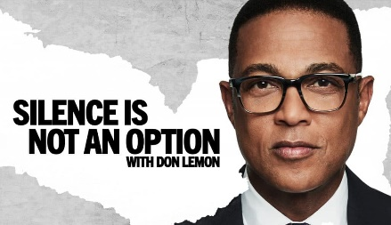
America is in crisis right now. A lot of people want to help, but have no idea where to start. In our new podcast, we’re going to dig deep into the reality of being Black and Brown in America, and explore what you can do to help find a path forward. We’ll have tough conversations with activists, artists, and thinkers about our nation’s deep racial divide. As we look for meaningful and lasting solutions, there is a lot to learn and unlearn. These conversations are going to be challenging—even uncomfortable—but they’re important. Because this time, we get to rebuild America together. Hosted by Don Lemon.
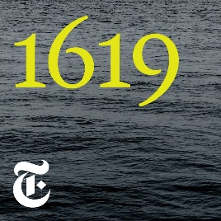
1619 (New York Times)
An audio series on how slavery has transformed America, connecting past and present through the oldest form of storytelling.

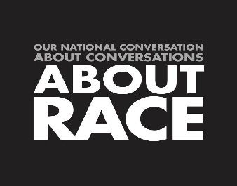
About Race
Co-discussants Anna Holmes, Baratunde Thurston, Raquel Cepeda and Tanner Colby host a lively multiracial, interracial conversation about the ways we can’t talk, don’t talk, would rather not talk, but intermittently, fitfully, embarrassingly do talk about culture, identity, politics, power, and privilege in our pre-post-yet-still-very-racial America. This show is "About Race."

Code Switch (NPR)
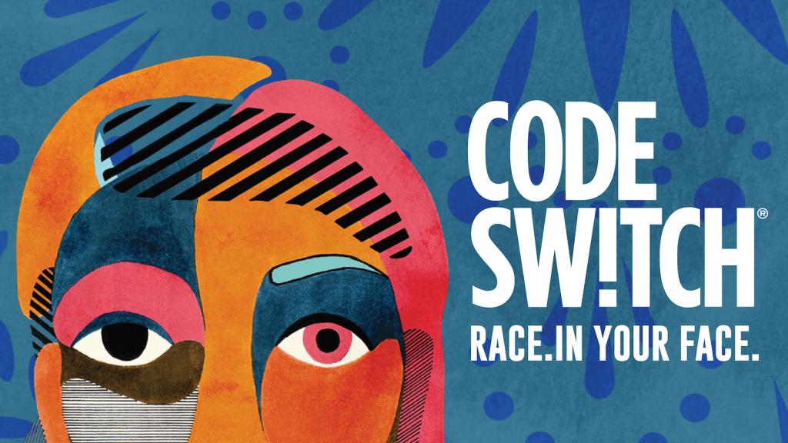
What's CODE SWITCH? It's the fearless conversations about race that you've been waiting for! Hosted by journalists of color, our podcast tackles the subject of race head-on. We explore how it impacts every part of society — from politics and pop culture to history, sports and everything in between. This podcast makes ALL OF US part of the conversation — because we're all part of the story.

Intersectionality Matters! hosted by Kimberlé Crenshaw
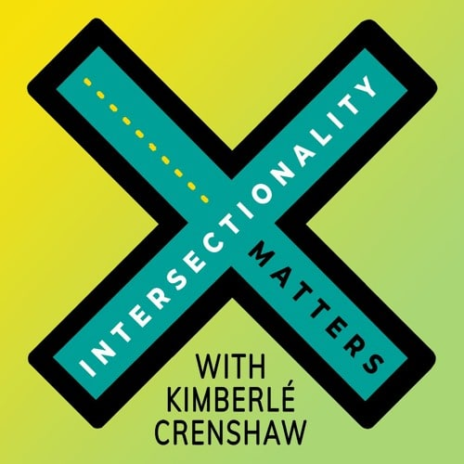
Intersectionality Matters! is a podcast hosted by Kimberlé Crenshaw, an American civil rights advocate and a leading scholar of critical race theory.

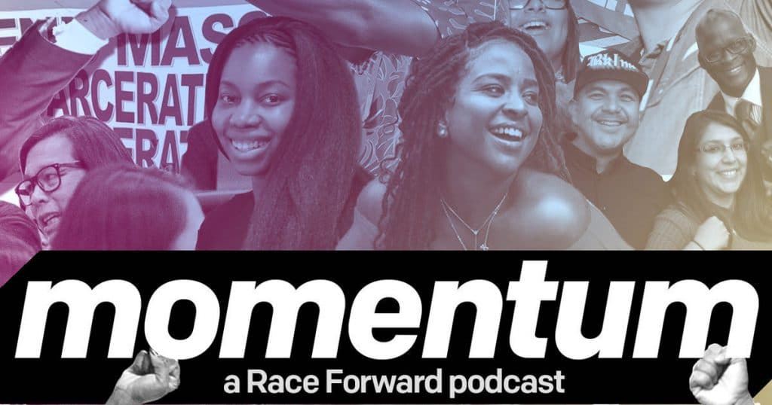
Momentum: A Race Forward Podcast
Momentum: A Race Forward Podcast features movement voices, stories, and strategies for racial justice. Co-hosts Chevon and Hiba give their unique takes on race and pop culture, and uplift narratives of hope, struggle, and joy, as we continue to build the momentum needed to advance racial justice in our policies, institutions, and culture. Build on your racial justice lens and get inspired to drive action by learning from organizational leaders and community activists.

Pod For The Cause (from The Leadership Conference on Civil & Human Rights)
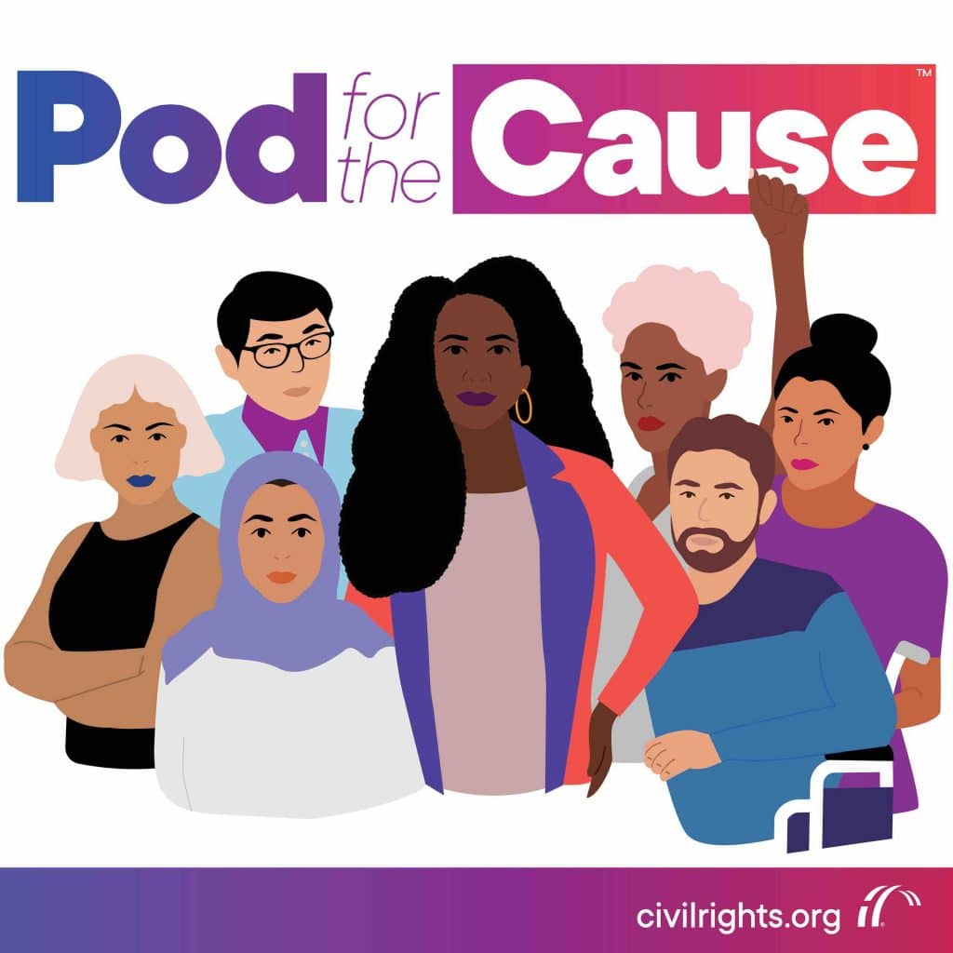
We’ve joined the airwaves to help spark conversation and activism on some of the most critical issues of today.
From the courts to immigration, we’re seeing unprecedented attacks on the values we hold near and dear. At Pod for the Cause, we’re going to tackle these issues and more. Our friends in the movement will be stopping by to have these conversations, and they promise to be real, straightforward and honest.
This podcast was created for those of you wanting to effect change, who understand the importance of restoring our democracy and want to engage in deep conversation around the issues.

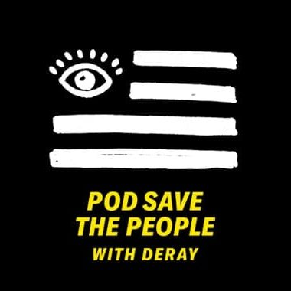
Pod Save the People (Crooked Media)
ACTIVISM. SOCIAL JUSTICE. CULTURE. POLITICS
On Pod Save the People, DeRay Mckesson explores news, culture, social justice, and politics with Sam Sinyangwe, Kaya Henderson and De’Ara Balenger. They offer a unique take on the news, with a special focus on overlooked stories and topics that often impact people of color.
There’s also a weekly one-on-one interview with DeRay and special guests, from singer/songwriter John Legend to Speaker of the House Nancy Pelosi. The experts, influencers, and diverse local and national leaders who come on the show go deep on social, political, and cultural issues. New episodes every Tuesday.

Seeing White
Just what is going on with white people? Police shootings of unarmed African Americans. Acts of domestic terrorism by white supremacists. The renewed embrace of raw, undisguised white-identity politics. Unending racial inequity in schools, housing, criminal justice, and hiring. Some of this feels new, but in truth it’s an old story.
Why? Where did the notion of “whiteness” come from? What does it mean? What is whiteness for?
Scene on Radio host and producer John Biewen took a deep dive into these questions, along with an array of leading scholars and regular guest Dr. Chenjerai Kumanyika, in this fourteen-part documentary series, released between February and August 2017. The series editor is Loretta Williams.

