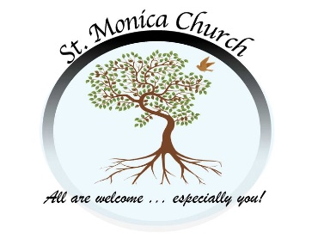
St. Monica Church Parish Event Form
(Please use this form for events, meetings or happenings that are NOT on our reoccurring calendar. If your ministry holds a meeting regularly, you do not need to fill this out.)
Please email this form to dhymes@dor.org and jlafler@dor.org.

Event: ________________________________________________________________
Description of Event: ___________________________________________________
Contact Person: ________________________________________________________
Email Address: _________________________________________________________
Address: ______________________________________________________________
Phone Number: ________________________
St. Monica Staff or Ministry Contact Person:________________________________
Date of Event: _______________________ Time: From _________ to ___________
(Alternate date if there is a calendar conflict) ________________________________

Where on the property will the event take place? (Please specify)
_____________________________________________________________________
How many participants do you anticipate? _________________________
What type of set-up or equipment will you be using? (tables, chairs, microphones, etc.) _________________________________________________________________
_____________________________________________________________________
Will you need support prior to event from our maintenance staff (set-up, take-down, etc.)? Please explain: _____________________________________________________________________
_____________________________________________________________________
_____________________________________________________________________

Do you need your event publicized in our bulletin, website, and or Facebook page?
__________________________________________________________________

